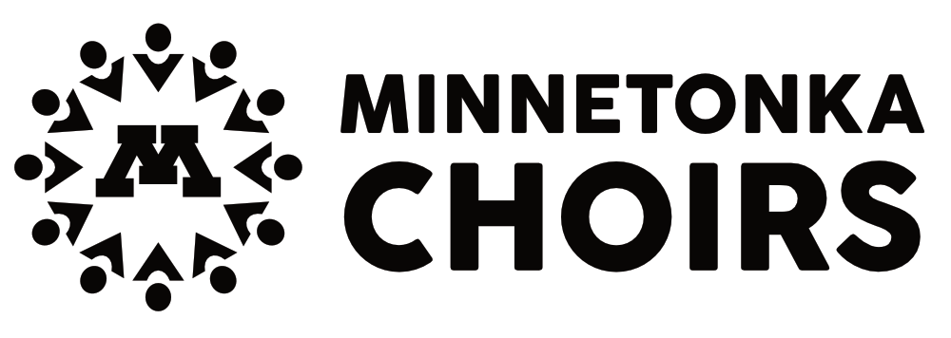

Find Your Voice in Minnetonka Choirs: Join Vocal Support!

You are invited to become a member of Vocal Support, the booster club for Minnetonka district choirs. Your membership supports all choral students and directors, elementary through high school. Parents, grandparents, and fans at large are encouraged to join!

2018-2019 Membership Information
- Benefactor’s Club: $500+ Includes CDs of all concerts and 2 center section reserved seats immediately behind the Concert Choir students at all MHS choir concerts.  - Patron’s Club: $250 Includes two reserved seats at  all MHS choir concerts.  - Director’s Club: $100  - Concert Club: $50  - Singer’s Club: $25 | Name:_____________________________________________  (Please list names as you would like them on the concert program.)  Address:___________________________________________  Phone:____________________________________________  Email:_____________________________________________  Email is used to confirm reserved seating, share concert reminders, events, and activities. Member names will appear in concert programs, but membership level will not be displayed.  Information will not be sold or shared.

Volunteer Information
We can’t do it without you! Please consider sharing your time, talent, and energy.
I am interested in helping with the following:
- Concert Help  - Robe Care and/or Tie Tying  - Ushering  - Concert/Event Photography  - Greenery Fundraiser  - Jingle & Mingle | - Music Library  - Liaison to ___________________________  (Please list school name, grade, choir.)  - June Senior Celebration Ice Cream Social  (Open to parents of non-seniors.)  - Other_______________________________

Membership in Vocal Support is Tax Deductible
Membership year is September 1 to August 31.  Please make your check payable to Vocal Support.  Mail this form and payment to:  Chris Gimse, VS Treasurer  6381 Teton Lane  Chanhassen, MN 55317 | Many businesses match charitable gifts for employees. Check with your human resources department to see if you can double your gift with an employer match!
You can also join online at minnetonkachoirs.org.

